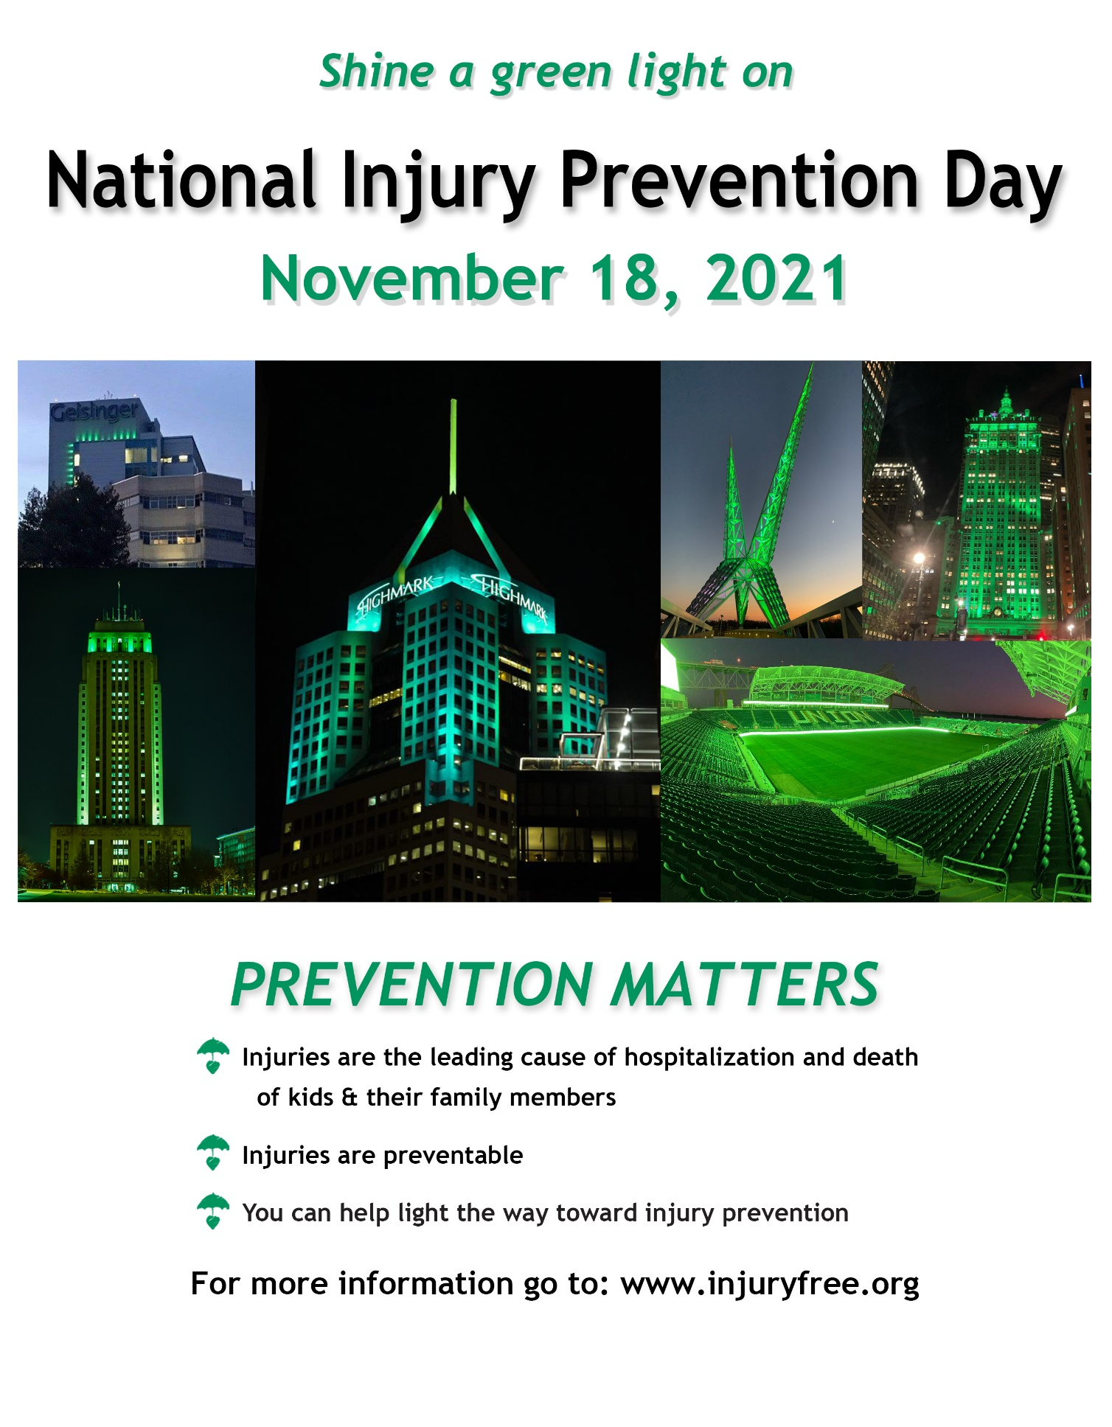

**Wear green Nov 18th to support National Injury Prevention Day!**

